Home | News | Contact | About

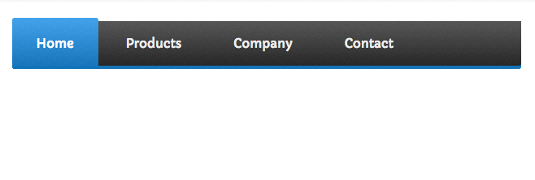

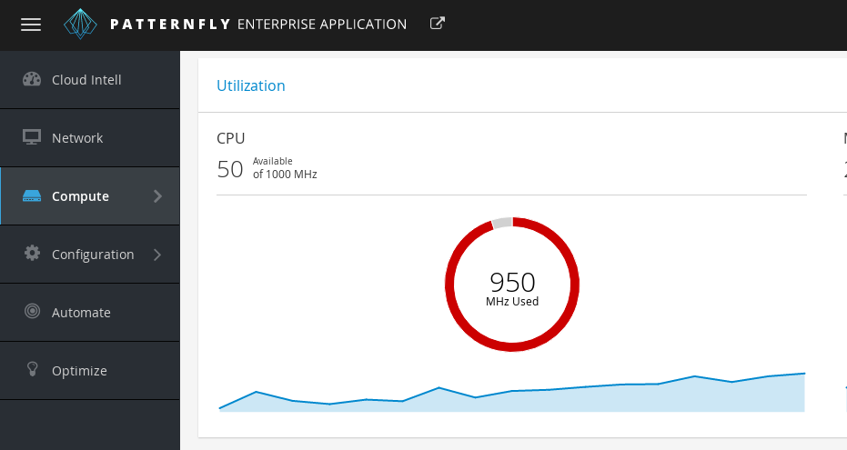

Navigation.
Basic Navigation. The w3-bar class is a container for displaying HTML elements horizontally.

navigation bar
A navigation bar (or navigation system) is a section of a graphical user interface intended to aid visitors in accessing information. Navigation bars are implemented in file browsers, web browsers and as a design element of some web sites.

Without navigation,
websites can appear unstructured and organised. Thenavigation bar or tools is a clear indication that your website is filled with knowledge and depth. ... Navigation is important because your readers don't want to figure out how your website works. Good navigation can speed up the viewers search.

